How to NOT sound silly to nerds: Guide to correct pronunciations!

-Dharvi Verma, Bharati Vidyapeeth College of Engineering

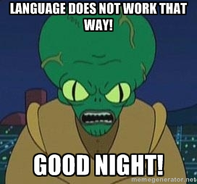

“Hey, that’s not how you pronounce meme!”  
  
You might have heard that from one of your friends. Nerds hate it when you get the technical terms wrong. You might want to be careful the next time you talk of a GIF or talk about how much you value Aereo (pronounced as Air-eh-oh), the TV streaming service that has divided opinions all over the world.

So, here we go:

1. GIF

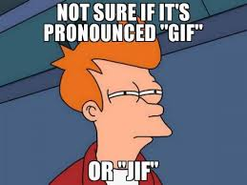

While you may be an expert at creating GIFs (Graphics Interchange Format), you may be pronouncing it with a ‘G’ while it is *actually* pronounced with a ‘J’. While the Oxford American Dictionary accepts both GIF and JIF, Steve Wilhite, the creator, clarified that it is actually JIF (that peanut butter, yep) while accepting an award in 2013.

2. Meme

This may be the thing which gives you your daily dose of laughter- surfing internet memes (9gag rings a bell, eh?). But chances are that you may, just may, be calling it ‘mem’ or ‘me-me’ while it is actually pronounced as ‘meem’. So, the next time you stare at a Ryan Gosling meme, make sure you don’t mispronounce it.

3. Cache

You may know all about this form of memory which stores data transparently for fast delivery in case of future requests. Just a titbit you need to know: it is pronounced as ‘cash’ and not ‘cashae’ or ‘cach’.

4. Adobe

Everyone’s favourite pfd file viewer, Photoshop software, Illustrator etc (you name it!), the multimedia giant Adobe is pronounced at ‘Uh-Doe-Bee’ and not ‘a-do-b’ or ‘a-doh-b’.   
  
5. OS X

Chances are that you are probably saying ‘oh-ess-ex’ when you talk about the operating system. Sorry folks, but it is pronounced as ‘oh-ess-ten’. X denotes the Roman numeral for the digit 10 here and not the alphabet X.